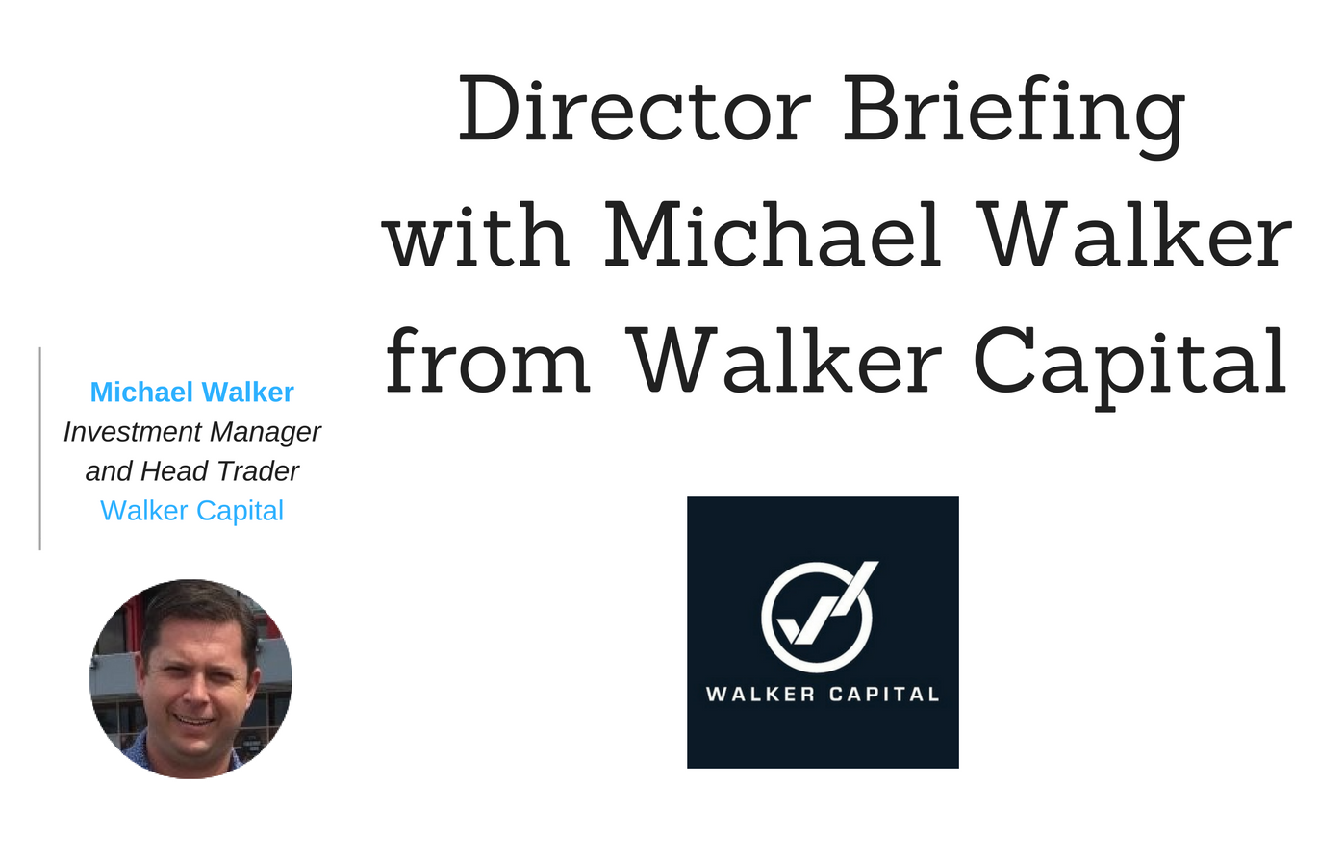
In this Director Briefing, Michael Walker, Investment Manager and Head Trader of Walker Consulting (Australia) Pty Ltd trading as Walker Capital (“Walker Capital”, “the Company”) discusses:
- Walker Capital’s innovative investment platform with a managed discretionary account (MDA) service
- More than 2,600 traders onboarded on the platform in 18 months
- Growth in Funds Under Management and expansion strategy

We spoke to Michael Walker, Founder, Investment Manager and Head Trader at Walker Capital, a firm that offers a managed discretionary account (MDA) service, specialising in rules based trading of derivatives.

Eden Exchange: Thanks for speaking to us, Michael. Firstly, what is Walker Capital? How does it work and what drove its creation?
Michael Walker: Walker Capital offers a managed discretionary account (MDA) service that allows our investors to access our specialised rules based trading of derivatives. With expert guidance from its seasoned investment managers, Walker Capital develops and manages sophisticated currency related trading models including CFDs (Contract For Difference) suitable for a variety of investors and investment strategies. The Company’s investment managers only trade in markets in which they believe they have a statistical edge and decisions are based on mathematical models derived from extensive statistical research and study.
Clients invest with us with full transparency and security of funds with the aim to achieve 20% net return on investment. There are no lock-in periods for the investment, clients can top-up and withdraw at any time.

Eden Exchange: Can you tell us a little about your professional background and career? What brought you to a leadership position at Walker Capital?
Michael Walker: I have set up and been involved in a number of companies over the years in Cloud Technology, Education and Property. During this period I traded for myself for over eight years. I found that most individuals struggle with trading due to them not being able to manage their own psychology and risks which are major keys to trading success. Setting up Walker Capital gives retail investors access to professional traders who have a track record of performance. Let me say that past performance is no guarantee of future returns, it is just an indication of what results have been achieved.

“I always found that most individual’s struggle with trading due to them not being able to manage their own psychology and risks, these are major keys to trading success.”

Eden Exchange: What makes Walker Capital different from other firms and solutions on the market?
Michael Walker: We are a boutique firm that focuses on trading derivatives forex and CFDs and aims to deliver a 20% net return for clients with complete transparency. Clients can login in real time and see what positions or trades we have taken and they can monitor the performance of their account at any time.

Eden Exchange: How do you generate revenue? How do you expect your core product mix will evolve?
Michael Walker: We generate revenue from management fees, performance fees and a rebate from brokerage. We currently have three model investments portfolios in Forex and CFDs. This will expand over the course of the year as we grow our team of professional traders.

“ In a year Walker Capital will have a solid foundation and a state of the art investment platform for clients”

Eden Exchange: Where do you foresee the greatest demand? What has the demand and uptake been like to date?
Michael Walker: We have had solid demand and uptake for our investment strategies with clients investing with us with an allocation of their portfolio. Some of this demand has come from individuals with self-managed super funds.

Eden Exchange: Can you tell us more about how your system manages risks? What is your greatest advantage?
Michael Walker: We managed risk in a number of areas as part of our risk management plan. We continuously monitor client accounts and have a notification process for clients. If the drawdown gets to a certain percentage, we ask for confirmation from the client if they want to continue in the strategy.
Utilising cloud based technology is a major advantage for us, streamlining client onboarding and transparency for clients, but at the same time this also strengthens our compliance by having robust systems.

Eden Exchange: What are the next steps in the development for the Company? Are you planning an international expansion?
Michael Walker: We are working on finalising the development of the investment platform and launching in the EU and UK. There are numerous legal and compliance requirements as each country has its own regulation. We are engaging lawyers and compliance specialists within the target regions to assist with a compliant entry into these markets.

Eden Exchange: What major trends should operators, especially stakeholders of the wealth management and trading sectors, need to be aware of? How will you capitalise on these trends?
Michael Walker: There is a trend for movement into Managed Discretionary Accounts (MDAs). For example, data from IMAP (The Institute of Managed Account Professionals Ltd) shows that as at 31st of December 2017, FUM (Funds Under Management) in Managed Accounts stood at $57.05bn. growing by $17.88bn from 2016. According to IMAP’s latest managed accounts FUM census, MDA growth over the six months to 31st July increased by 37.14 per cent ($6.21bn) to $22.93bn.
Walker Capital aims to capitalise on these trends. Investors are demanding transparency around ownership of their investments, especially when they are pursuing investments which are not correlated to the general market.

“Utilising cloud based technology is a major advantage for us, streamlining client onboarding and transparency for clients, but at the same time this also strengthens our compliance by having robust systems.”
Eden Exchange: What are you plans to further enhance your management team? You are planning on establishing an in-house sales team, how do you see this affecting the growth of the Company?
Michael Walker: We have just engaged a Chief Financial Officer who has worked for Optus, Skype and Microsoft in commercial and strategy roles. We are strengthening our advisory board over the coming months, working through a short list of suitable individuals. We are currently building our in-house sales team with one Business Development Manager now and a team by February 2019. With the right team and management we will accelerate our growth to achieve our targets and milestones.

Eden Exchange: What are some challenges the Company has encountered so far? On the other hand, what are some key achievement you are proud of to date?
Michael Walker: During the initial testing period, when setting up the Company, we managed to bring in over $4 Million of FUM in under 6 months on a very small marketing budget. This was a major achievement.
A main challenge for us will always be aiming to achieve our target net return of 20% p.a. That’s why I built tradingstats.com, an analytics platform for traders which connects to over 200 brokers worldwide. As we grow we need to build our team and traders are a core part of our business.
The question I asked myself was “How do you find traders who are good and consistent at what they do?”. With no marketing budget I now have over 2,600 traders on the platform in 18 months. We will be growing the user base to bring the best traders to Walker Capital.

Eden Exchange:What type of strategic partners are you looking for?
Michael Walker: We are looking for strategic partners who have access to a network of individuals who are looking for strong investment returns using a small allocation of their portfolio.

Eden Exchange: Where do you see your business in a year from now? What does the expansion plans look like and what milestones do you need to hit before you can scale significantly?
Michael Walker: We are moving in the right direction, ensuring we have an experienced team in all areas including compliance. In a year, Walker Capital plans to have a solid foundation and a state of the art investment platform form for clients, so we will have the tools and resources to scale.

Eden Exchange: Thank you

For more information about Walker Consulting (Australia) Pty Ltd, please visit the Walker Capital page on the Funding Strategies website (log-in required, joining is free). Alternatively, please contact Dr Mark Rainbird and his team by phone: +61 7 3160 2840 or email: brisbane@fundingstrategies.com.au.
DISCLAIMER: Eden Exchange Pty Ltd and Funding Strategies Pty Ltd have taken all reasonable care in publishing the information contained in this Director Briefing. It is information given in a summary form and does not purport to be complete. The information contained is not intended to be used as the basis for making any investment decision and you are solely responsible for any use you choose to make of the information. We strongly advise that you seek independent professional advice before making any investment decisions. Eden Exchange Pty Ltd and Funding Strategies Pty Ltd are not responsible for any consequences of the use you make of the information, including any loss or damage you or a third party might suffer as a result of that use.

For previous Director Briefings by Funding Strategies and Eden Exchange, or to receive future Director Briefings, visit https://www.businessbuyinvest.com/the-director-briefing-service/ or phone +61 3 8658 2292.

IMAP / Milliman Latest Managed Account FUM Census as at 31 December 2017

