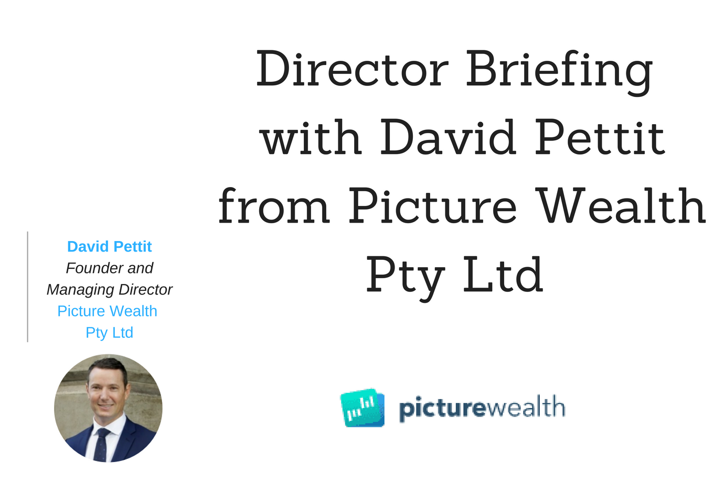
In this Director Briefing, David Pettit, Founder and Managing Director of Picture Wealth Pty Ltd (“PictureWealth”, “the Company”) discusses:
- PictureWealth’s innovative platform educating and empowering people through digitised financial guidance
- Creating a singular picture of an individual’s wealth in a private, secure & convenient way
- The Company’s business outlook and expansion plans
We spoke to David Pettit, Founder and Managing Director of Picture Wealth Pty Ltd. PictureWealth is an interactive, connected platform for people to review and learn about their money so they can better manage their financial health and wellness. The platform creates a true picture of their wealth, a so called “Welfie”, so they can easily understand, improve and optimise their finances.

Eden Exchange: Thanks for speaking with us, David. Firstly, can you tell us a bit about the spark that ignited PictureWealth? What is your background and experience?
David Pettit: PictureWealth began as a sketch on a piece of paper while I was on a flight between Perth and Singapore and I was pondering the increasing complexity of money in our lives, and how technology could be used to get full transparency across finances on a single screen. Luckily there were no exciting movies on the flight, so I decided to draw the idea up on a single page. Basically, the thought was to make everything less complicated, visible and easier. It soon became obvious that this would be hugely beneficial, not only for me, but for everyone! Hence, PictureWealth was born.

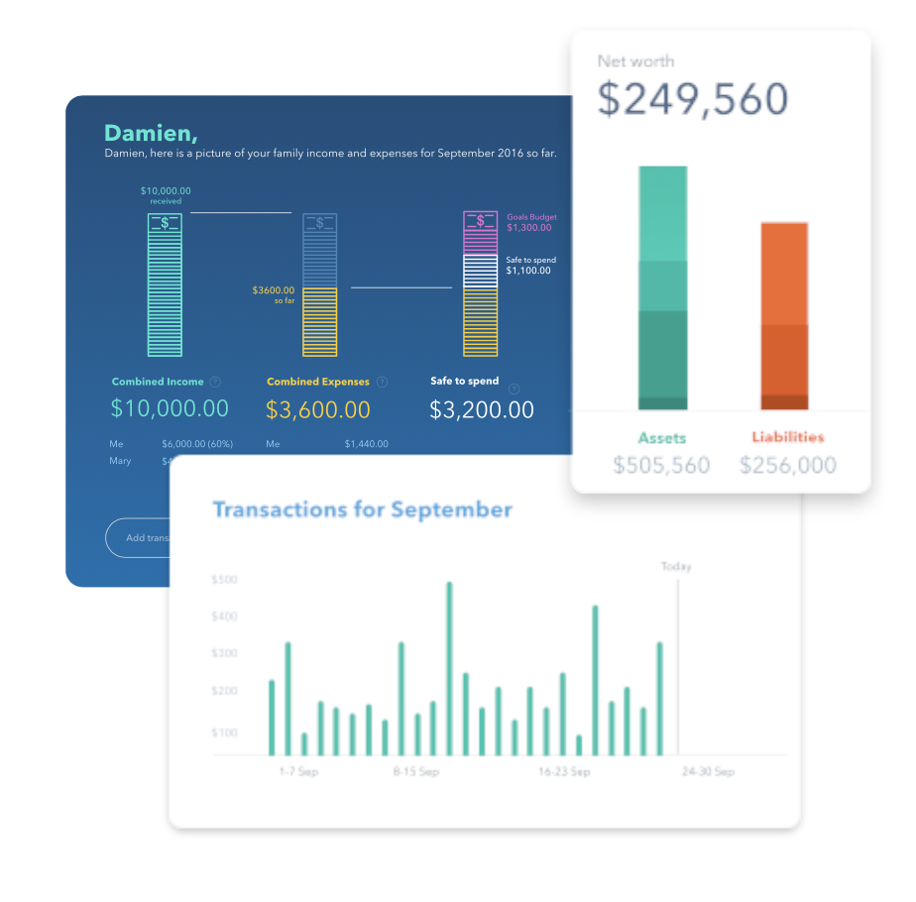
As a career long financial adviser and award-winning entrepreneur, I often pondered how high-quality advice, usually limited to those with a lot of money could be made available to everyone, for free. I soon concluded that the digitisation of financial advice was inevitable, so why not be at the forefront of that journey and help build it? For me, the future of advice empowers people to have full visibility across their money. Our technology can advise people on what to do and hence remove the financial uncertainty that exists in day-to-day life.

PictureWealth provides you with a “Welfie” - basically a snapshot of your personal finances

Eden Exchange: What does PictureWealth do?
David Pettit: Most people are not organised in relation to their money. PictureWealth has created a space for you to go, so you can get your money matters organised and stay that way. The system’s algorithms focus on educating and empowering you by delivering customised financial guidance on a large scale, at a low cost.

In short, PictureWealth offers the best singular picture of your wealth in a private and secure way and helps you make financial decisions that save you money, as well as make you money. By improving financial literacy, we help you make better financial decisions for yourself and your family.

Our guiding principles about money are simple: Make it, Save it, Grow it and Protect it. PictureWealth deals with all these principles and empowers you to make educated decisions on what you can do better or differently. The technology brings all aspects of your money together into a single picture, a snapshot of your wealth, and then provides a place where you can understand, improve and optimise your money matters.

Your “Welfie” is your Wealth Selfie, a single screen snapshot about you and your money. It’s a high level picture of your money like you’ve never seen it before.
You can add the things that you own, the money that you owe, the big goals you want to achieve, your insurances and your investments. You can even connect all of your bank accounts into one place to help you understand how you are spending and saving. Imagine knowing exactly how much you spent on coffee and movies, and how much you are (or are not) saving. The “Welfie” assists in giving you key insights, actions and recommendations to improve your wealth and to help you stay on track. In other words, you paint the picture and then you can sit back and let the right advice find you.

Eden Exchange: What makes you different from other solutions on the market? What gap in the market are you filling and why is it a good time to be servicing the private financial planning industry?
David Pettit: Unlike some of the other budgeting and money-management apps out there, PictureWealth is continuing down the path of fully digitised financial advice across all aspects of personal finance. We help you build your financial picture, and then improve it with digitised guidance and advice.
With the banking royal commission at hand, the future of financial advice has never been so uncertain, but with uncertainty comes opportunity. There is a great opportunity to now launch a technology based solution that looks after people.

Eden Exchange: How do you generate revenue?
David Pettit: We are conducting mergers and acquisitions of financial services businesses and adding value to the clients that those business service. We are improving their financial products and services and we generate revenue from Investment, Superannuation, Mortgages and Insurance. Importantly because of our capacity to scale, it still works out to be extremely affordable to be a member of the PictureWealth program. The Company will be in revenue and profitable as soon as the first acquisition has been completed.
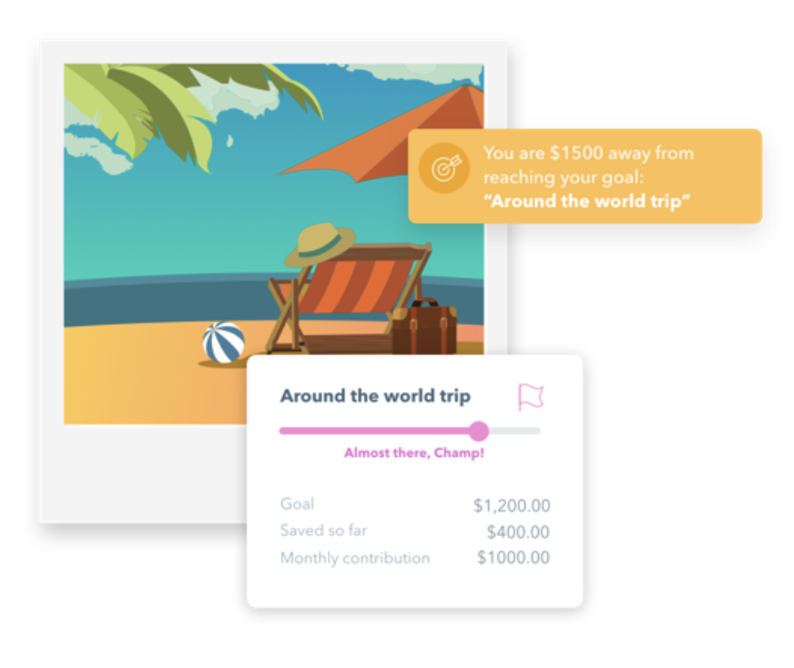

By improving financial literacy, we can assist people to make better financial decisions for themselves and their families.

Eden Exchange: Where do you expect to see the greatest demand for the product to be coming from? How has the market response been to date? In which markets do you see the most potential growth and reach?
David Pettit: The greatest demand will come from the 80% of Australians who are currently unadvised because they don’t know where to start. The market response has been great. The reason PictureWealth is proving to be successful is that the problem we are solving is not just a domestic problem for Australian residents, it is a global issue. Investors like PictureWealth due to our focus on improving financial literacy, offering tailored financial education and improving people’s financial health (which in turn improves their physical and mental health).
In terms of markets, PictureWealth is a global facing business that has been built and launched in the most heavily regulated environment in the world, Australia. Thus, it is easy for PictureWealth to enter foreign markets by simply stripping back complexity. We are headquartered in Perth where we share the same time zone with 60% of the world’s population, therefore Asia is a big focus for us.

Eden Exchange: Can you tell us more about how you are working with Blockchain integrations? How do you plan on engaging your FLIQcoins with crypto-currency?
David Pettit: Our focus on creating positive behavioural change is demonstrated in the way we incentivise and reward our members for adopting healthy financial habits by issuing them with FLIQcoins. In summary, the more organised someone is in relation to their money, the more rewards they can earn.
A reward token or crypto-currency can have an enormously positive impact on the health and wellbeing of individuals and broader populations FLIQcoins positioned on the Blockchain act as the reward currency that incentivise our members for improving their financial world. Whilst FLIQcoins are not yet live, we are looking forward to introducing them to make managing money more fun.

Eden Exchange: What are the next steps in the development for the company?
David Pettit: We have an impressive pipeline of new features and functionality, all designed to make the PictureWealth experience more engaging and rewarding. Part of that will be taking FLIQcoins live, while launching our chatbot and marketplace. We don’t want to reveal too much at this stage, but rest assured the platform will revolutionise the way people interact with their money. Watch this space!

Eden Exchange: What major industry trends operate in your sector that especially stakeholders within the wealth management sector need to be aware of? How will you capitalise on these trends?
David Pettit: Artificial intelligence and machine learning are both trends that have been integrated into our platform already and will continue to infuse the experience at many levels.
FLIQcoins are one example of how we are harnessing blockchain technology to bring a new way of transacting with goods and services and influencing member behaviour.
Ecosystems are another trend that we are watching and incorporating. Businesses will no longer operate as silos or in isolation and will become part of communities of like-minded providers who find synergy in working together and adding value to their clients. The financial industry automatically lends itself to this concept and PictureWealth can integrate many partners via the nature of the online setting.

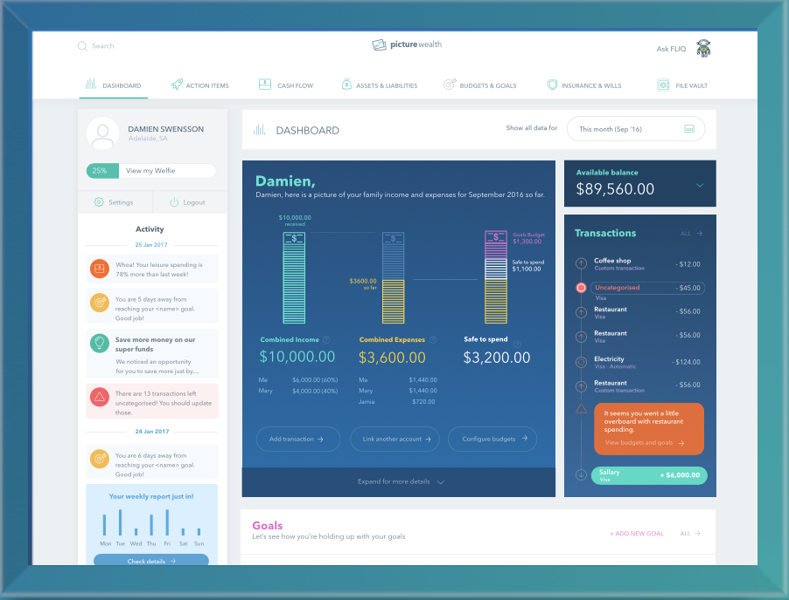

PictureWealth can integrate many partners via the nature of the online setting.

Eden Exchange: You have an experienced management team and board in place. What strengths do they bring to the company? What opportunities does this create?
David Pettit: PictureWealth is the culmination of years of experience and expertise. I have been fortunate enough to have worked with some of the most brilliant minds in finance and technology. This has created a potent mix of ingredients for a product that intersects several fields of expertise. Our team contributes skills in innovation, finance, technology, marketing, sales and behavioural economics, all of which play a part in our member journey.
The opportunity is that we can take an industry, that has until now been fragmented and considered a bit boring, and transform it to be engaging, valuable, rewarding and impactful. Technology is allowing us to be creative and proactive so that we can instill some excitement into financial literacy and the power that comes with organising your money.
Neal Cross is our Chief Innovation Officer. Neal is also the Chief Innovation Officer at DBS bank in Singapore with more than 20 years’ experience in technology, innovation and financial services. He was awarded the World’s Most Disruptive Chief Innovation Officer by Wozniak and Branson in 2016 and is known as one of the top innovation thought leaders across the planet. Neal has shared his thoughts as a speaker at G20, is an advisor to several government agencies and is on the Singapore future corporate capabilities and innovation committee. Prior to DBS, Neal was at MasterCard, where he was responsible for driving innovation as Vice President of MasterCard Labs in the company’s Asia/Pacific, Middle East and Africa regions and prior to this was the Financial Services Industry Director - Asia for the Microsoft Corporation.
Douglas Faudet is an Advisory Board Member. He was most recently Vice Chairman of DDB Worldwide, Asia Pacific region. Douglas worked for DDB for nearly 30 years in many countries including New Zealand, Japan, Hong Kong, Korea, China, India, Vietnam, Taiwan, Malaysia and Thailand. As CEO of DDB New Zealand he built a business that is now a leading and respected communications group. Before he moved to Asia he was appointed Vice Chairman of DDB Asia Pacific, a title he retained throughout his career with DDB Worldwide. Douglas is an international advertising and communications powerhouse. He has worked with many famous global brands including McDonald’s, VW, Audi, J&J, Pepsi, Kraft Foods, P&G and many more. He served the McDonald’s account in many parts of the world over a 28-year partnership.

Lauren Wyper is our Chief Customer Officer. Lauren’s background in nutrition led her to Discovery Vitality in South Africa, where she worked in the wellness division on research and development. She was involved with various health improvement projects based on the application of behaviour science. She is passionate about both wellness and organisation across all aspects of life. She is always looking for ways to do things more efficiently to streamline daily life. Lauren sees the synergies between wellness and financial behaviours and believes that PictureWealth provides a revolutionary hybrid solution that can positively impact both.

Eden Exchange: Can you tell us a bit more about some key achievements and challenges the company has encountered so far? Do you see any potential future challenges?
David Pettit: As with many new ideas, it is challenging to know when to draw the line in the sand and officially launch. We have only scratched the surface of what we want to do with PictureWealth and so we have had to be okay with revealing the platform at a point where its functional but certainly not perfect. There is a famous quote by Reid Hoffman, the founder of LinkedIn, which really resonates with some entrepreneurs: "If you are not embarrassed by the first version of your product, you’ve launched too late."

“We don’t believe that doing things the way they always have been done is going to take us where we want to go, so finding the right people with innovation, technical, regulatory and behavioral change expertise will always be on our agenda.”

We have had to be comfortable with the fact that our product will constantly evolve and improve, as is the nature of this space, and we wanted to launch to get some member feedback on what we can be doing better and differently. Staying relevant and exciting will keep us on our toes as we focus on new and better ways to help people manage their money and get closer to financial happiness.

Eden Exchange: What is the profile of the strategic partner you are looking for?
David Pettit: We are looking for businesses who are aligned with our mission – to bring financial happiness to the planet. Money touches everyone and we can work in so many spaces where organisations want to add value to their clients or members. Consider an accounting firm who wants to extend the scope of their services beyond tax and balance sheets, or a company who wants to improve employee wellness and productivity levels through better financial management. If a company sees scope for improving financial literacy and wellness within their employees or clients, we can work with them.

Eden Exchange: Where do you see your business in three months as well as a year from now? What do the expansion plans look like and what do you need in order to scale significantly?
David Pettit: In three months from now, we expect that we will have completed several significant mergers and acquisitions, as well as a significant investment round. This will put PictureWealth in the position of enormous potential in terms of funds under management and opportunities to impact individual lives. We are always looking at new ways to innovate and we are open to investigating unchartered territory as far as how we impact people’s financial worlds is concerned. We don’t believe that doing things the way they always have been done is going to take us where we want to go so finding the right people with innovation, technical, regulatory and behavioral change expertise will always be on our agenda. Fortunately, being an online platform, our ability to scale is unprecedented in this space and has been an integral part of our business model.

Eden Exchange: Thank you for your time David.

“PictureWealth is a free and exclusive system available for understanding and managing your complete financial picture. A picture paints a thousand words. We help you paint your financial picture by organising all your money matters in one place. Your Welfie (Wealth + Selfie) shows you the big picture of your current financial status, including your net worth, income, cash flow, super, insurance, estate planning and goals.”

For more information about Picture Wealth Pty Ltd, visit the Company’s page on the BlueMount Capital website (sign off require). Alternatively, please contact Dr Mark Rainbird and his team by phone on +61 7 3160 2840 or email brisbane@bluemountcapital.com .
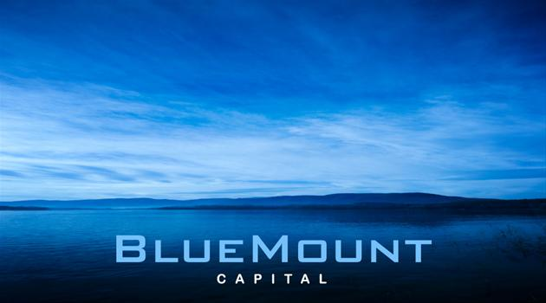
DISCLAIMER: Eden Exchange Pty Ltd and BlueMount Capital (QLD) Pty Ltd have taken all reasonable care in publishing the information contained in this Director Briefing. It is information given in a summary form and does not purport to be complete. The information contained is not intended to be used as the basis for making any investment decision and you are solely responsible for any use you choose to make of the information. We strongly advise that you seek independent professional advice before making any investment decisions. Eden Exchange Pty Ltd and BlueMount Capital (QLD) Pty Ltd are not responsible for any consequences of the use you make of the information, including any loss or damage you or a third party might suffer as a result of that use.
For previous Director Briefings by BlueMount Capital, or to receive future Director Briefings, visit https://www.businessbuyinvest.com/the-director-briefing-service/ or phone +613 8658 2292.

